Boyd Tackle

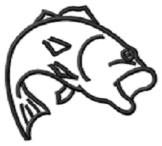

“For All Your Fishing Needs.”

Address: 150 Magnolia Dr. Abbeville, SC 29620

Phone: (864) 378-7618
Email: boydtackle1@gmail.com

Boyd Tackle is a tackle company that provides good and durable tackle for serious fishermen. We make all our tackle and we also put a lot of effort into making it. We mostly make jigs and shaky heads.

